**NETWORK DAIGRAM**

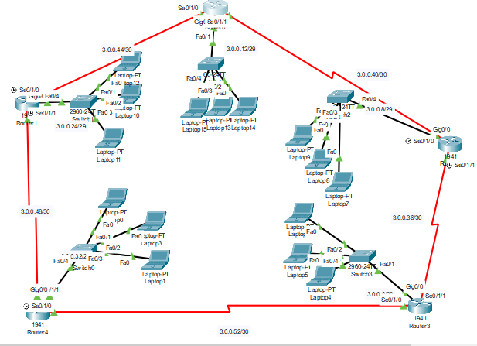

**EIGRP CONFIGURATION OF ALL ROUTERS:**

**ROUTER 01:**

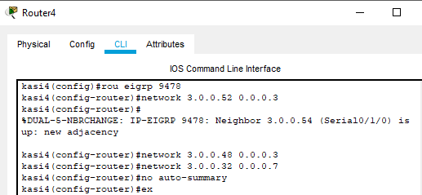

**ROUTER 02:**

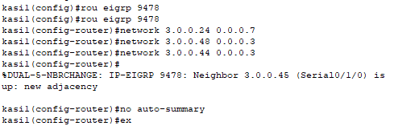

**ROUTER 03:**

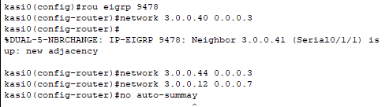

**ROUTER 04:**

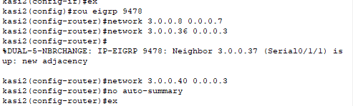

**ROUTER 05:**

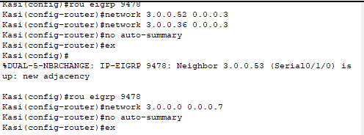

**SHOW IP ROUTE COMMAND**

